Waffle Charts and Word Cloud

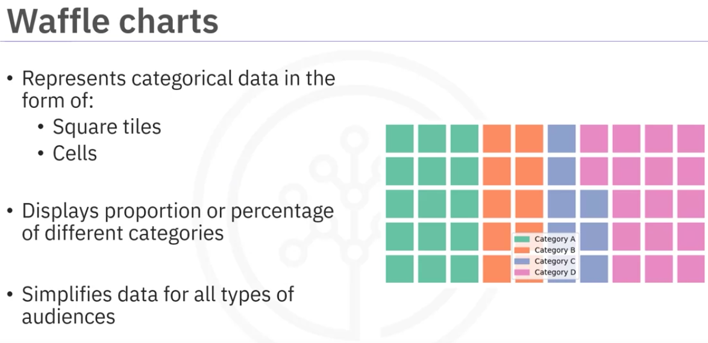

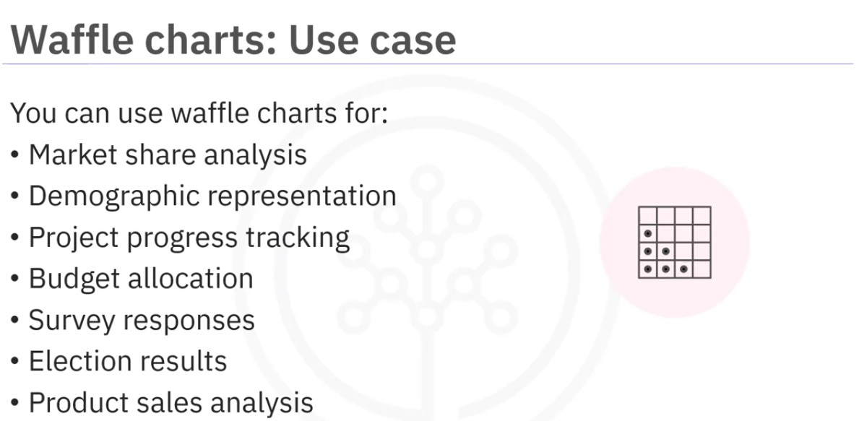

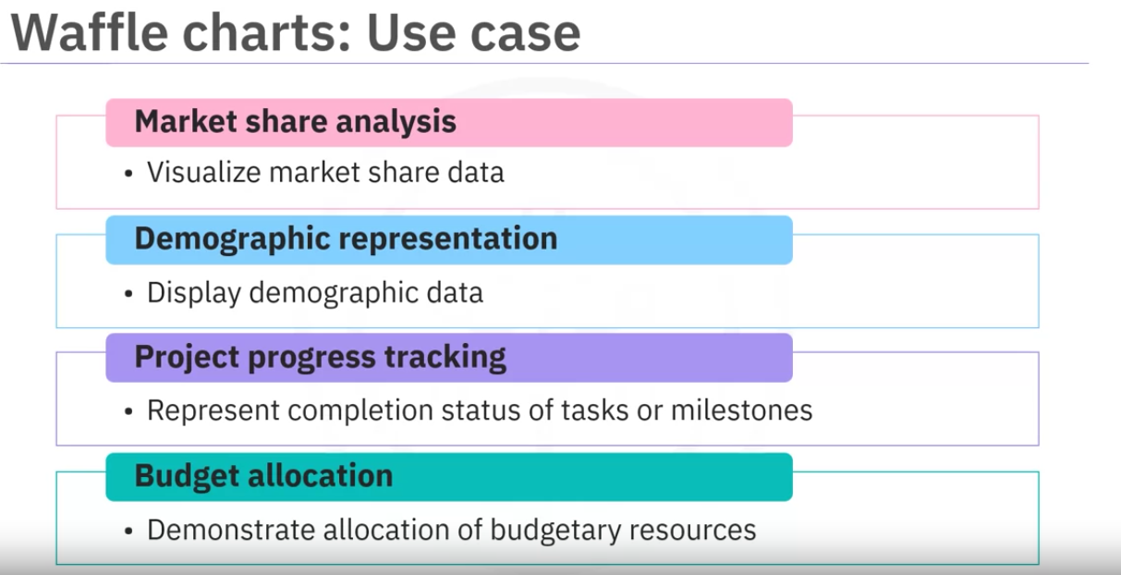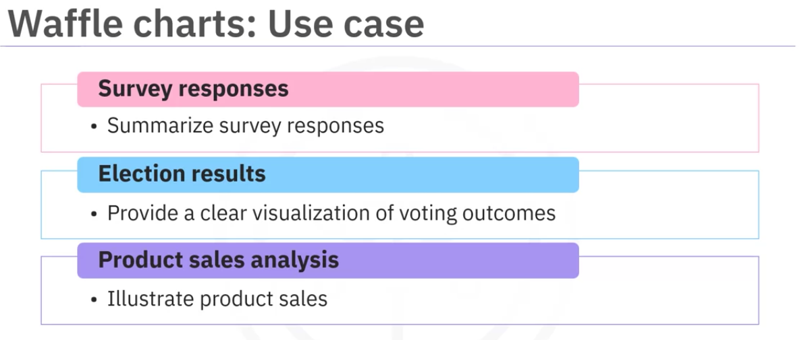

We can import Waffle from pywaffle library

we can easily create waffle charts that represents categorical data

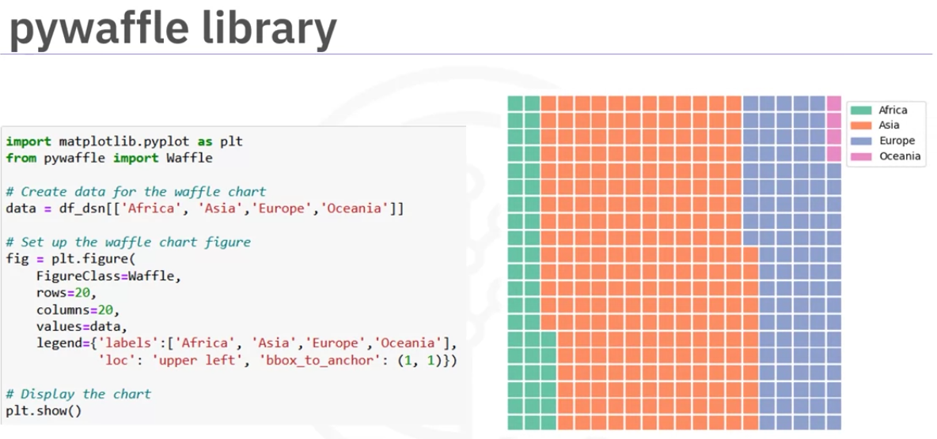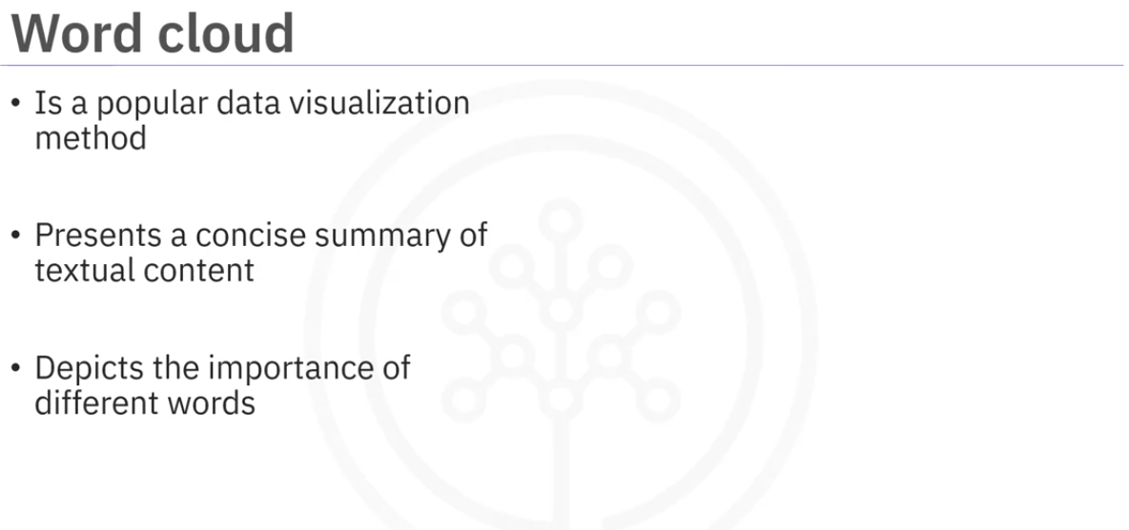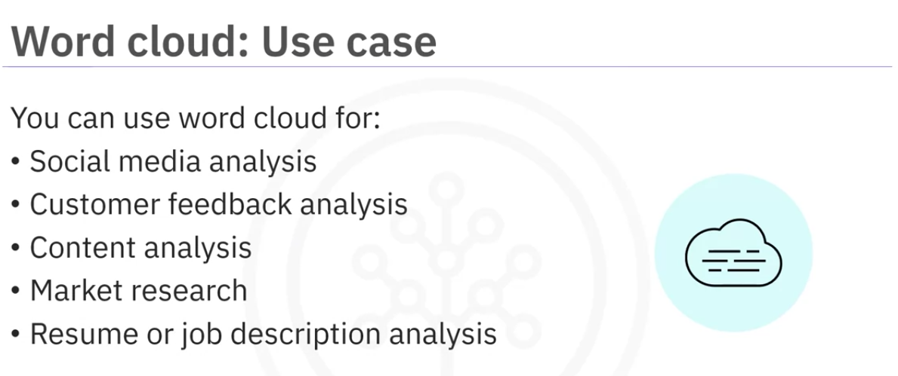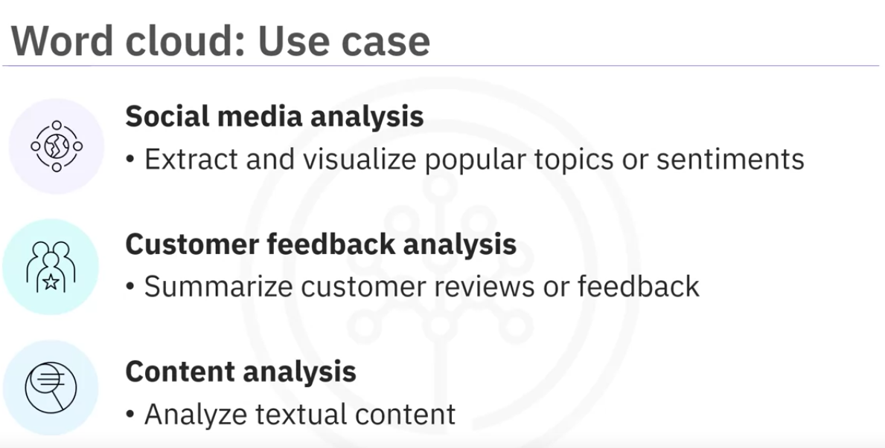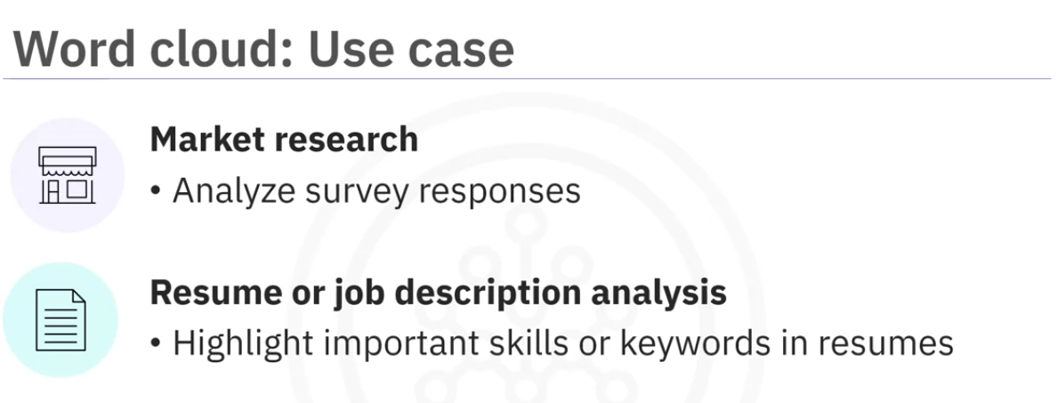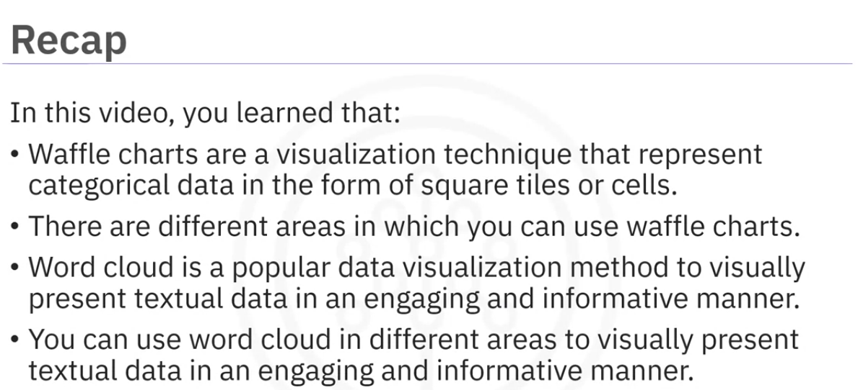

Seaborn Regression plots

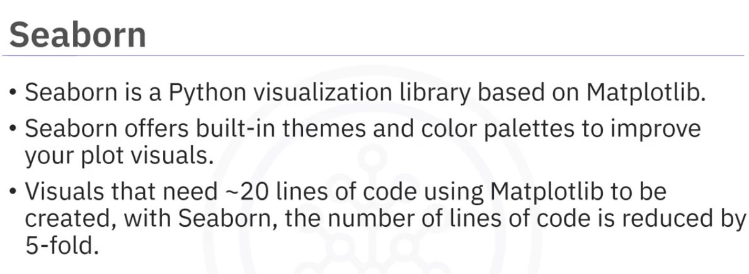

Integrates well with numpy and scipy so it can be used to combine statistical analysis and visualization. T

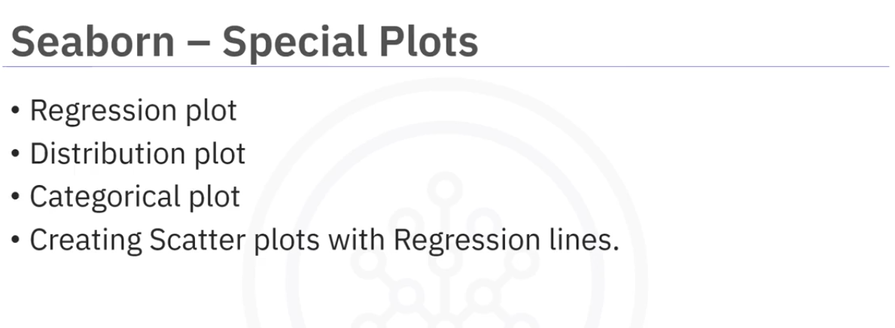

Regression plots, distribution plots and categorical plots are particularly useful for analysing data and modelling relationships.

Seaborn works well when we have more complex visualizations and statistical analysis

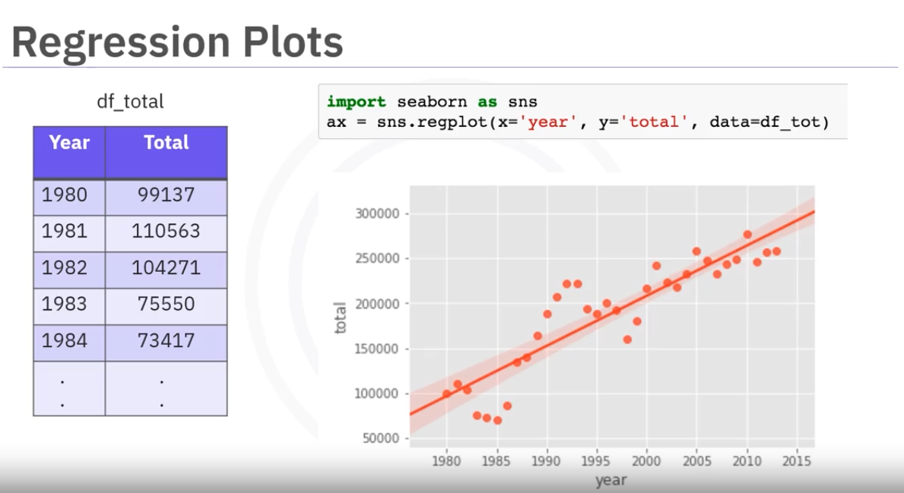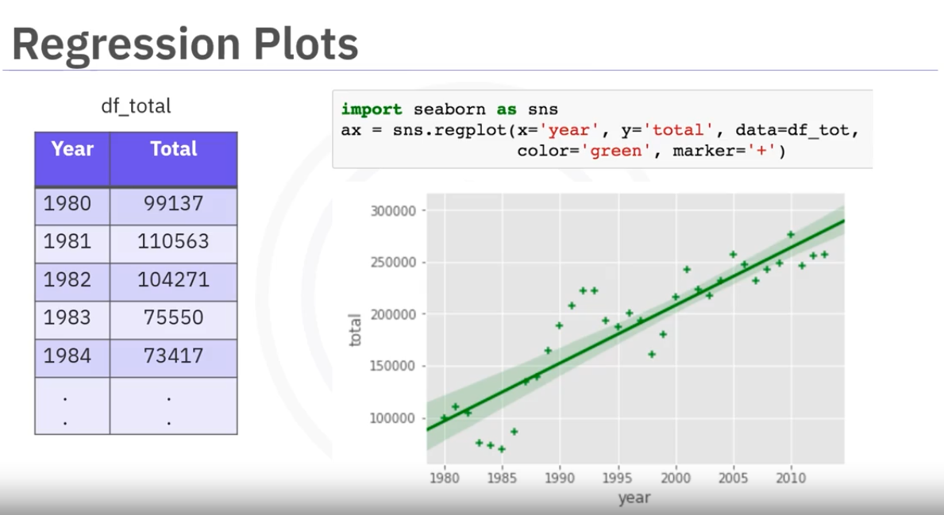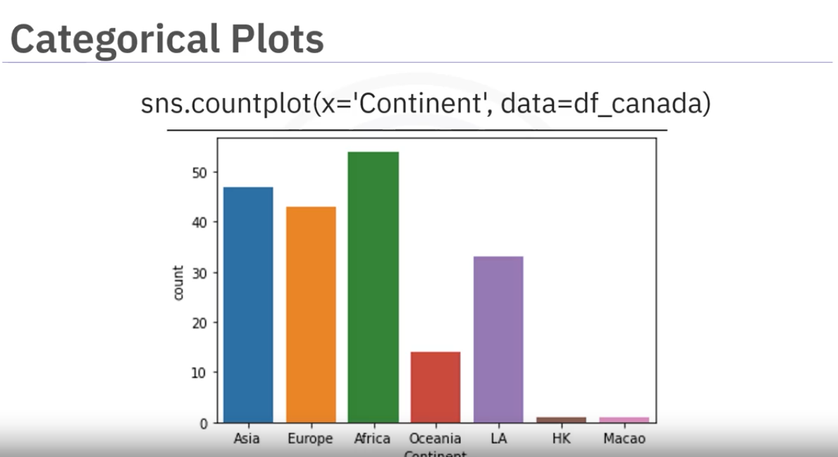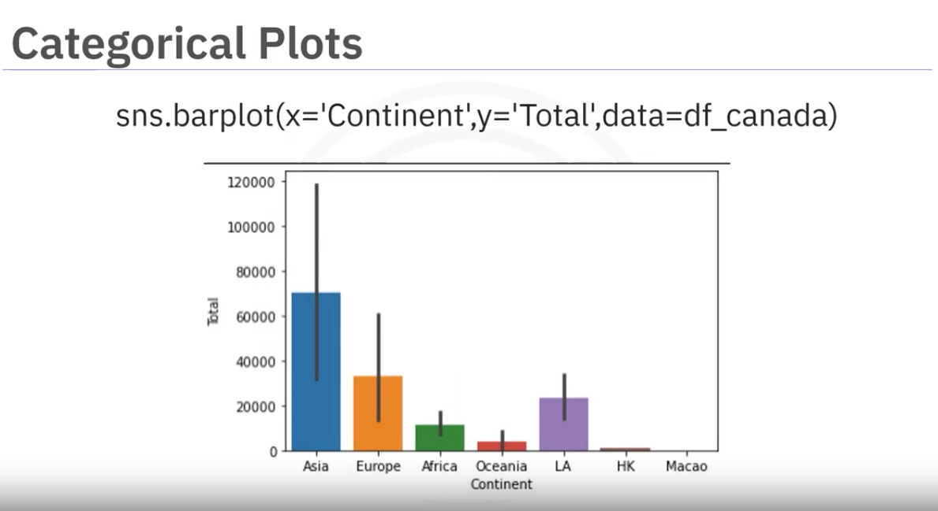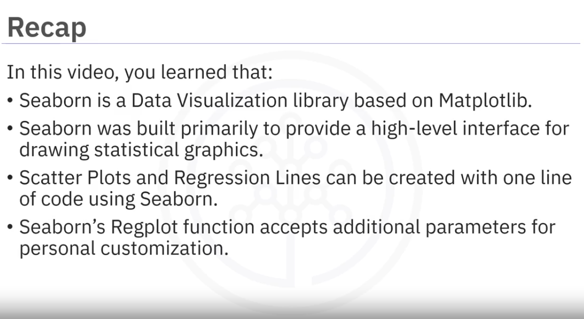

Folium

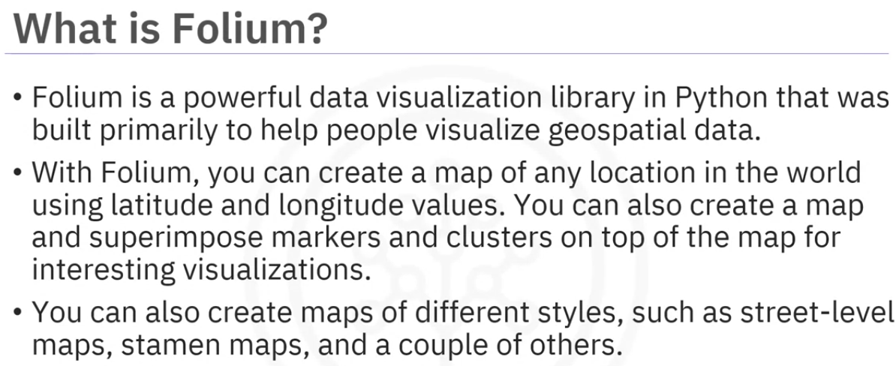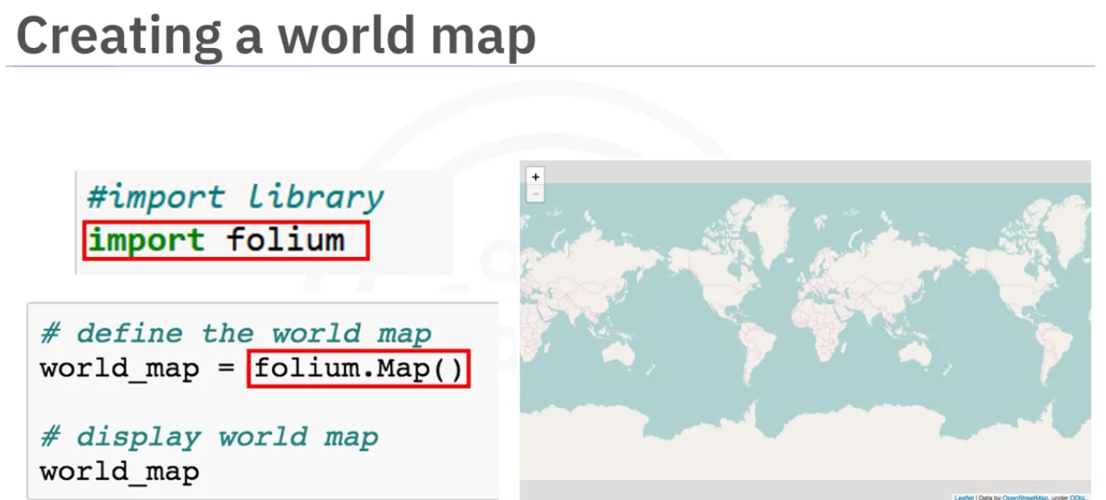

The Map class helps to create the word map.

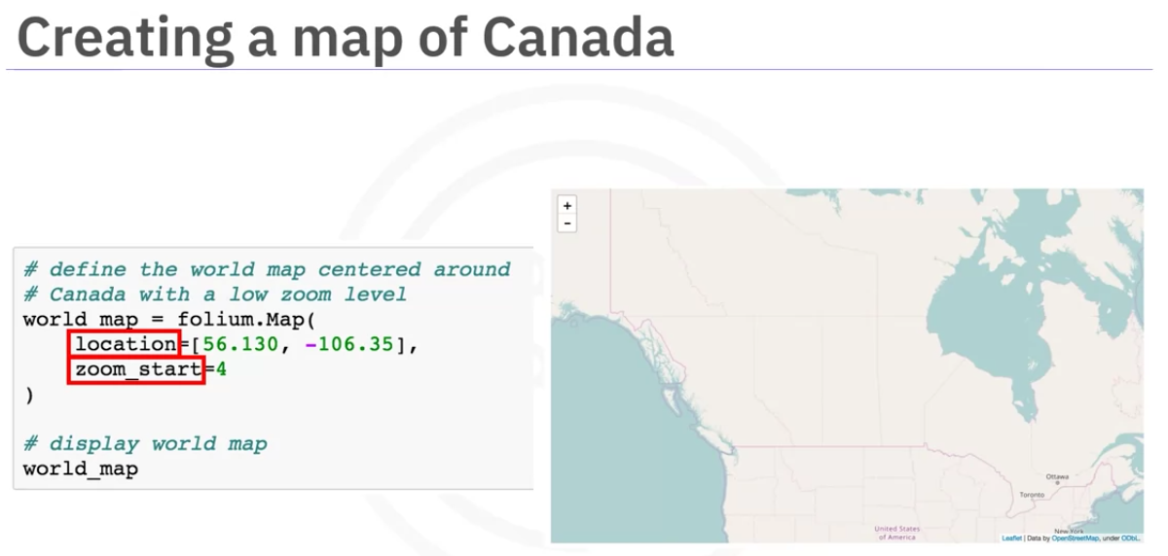

The location property helps to focus on a specific locatio. we can set initial zool level.

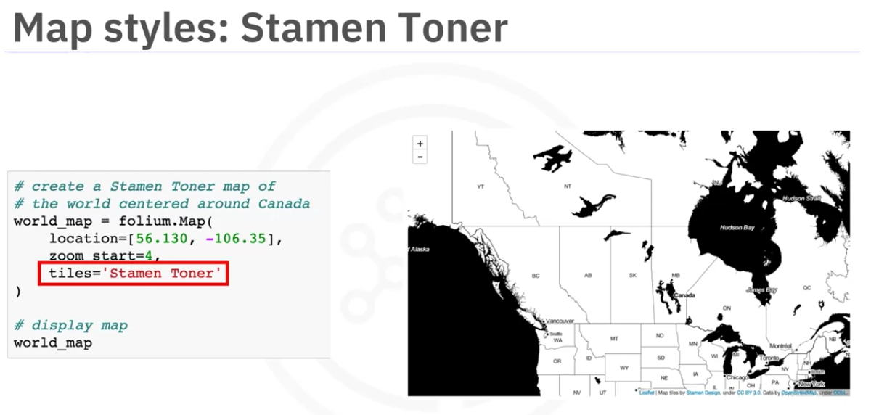

The Stamen Toner map helps to show the river meanders and costal zones. It is a style that we use. We can use the title attribute to set it.

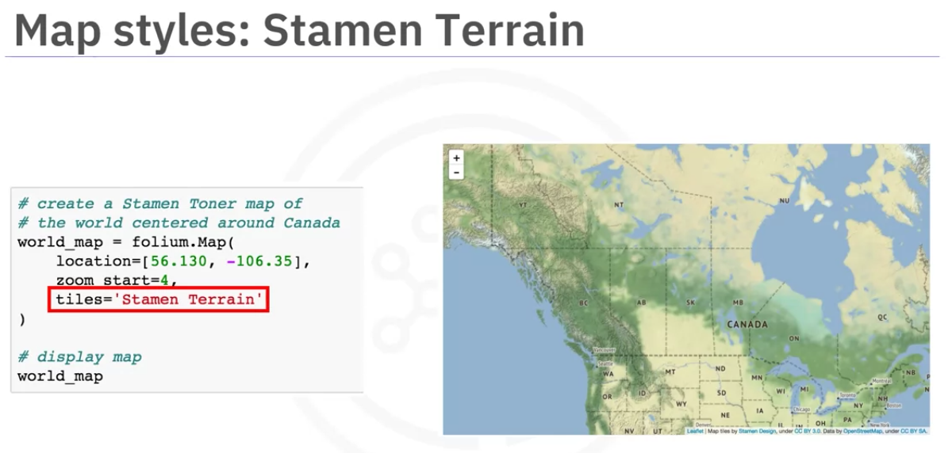

We can also set it to Stamen Terrain to see terrains. This is helps to see hill sides and natural vegetation.

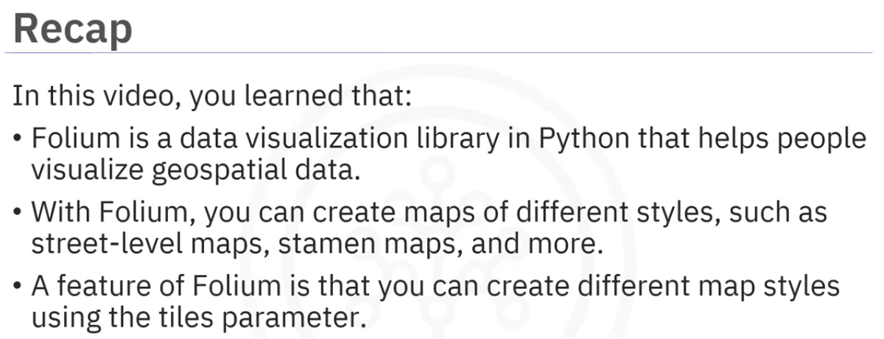

Maps with Markers

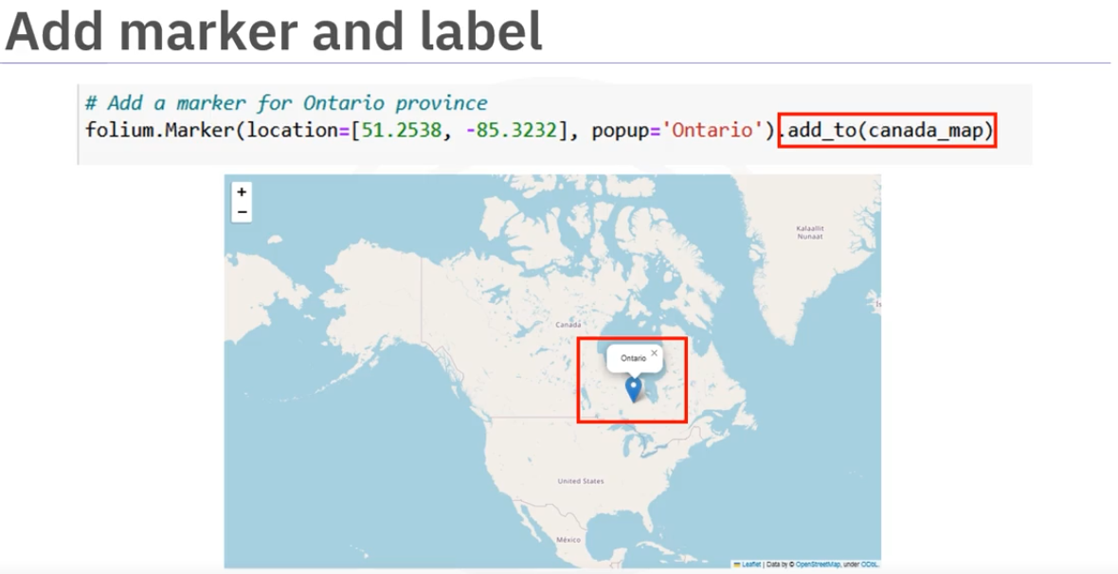

The Marker class helps to create a marker by providing location and popup properties

the add_to method helps to add the marker object to map object.

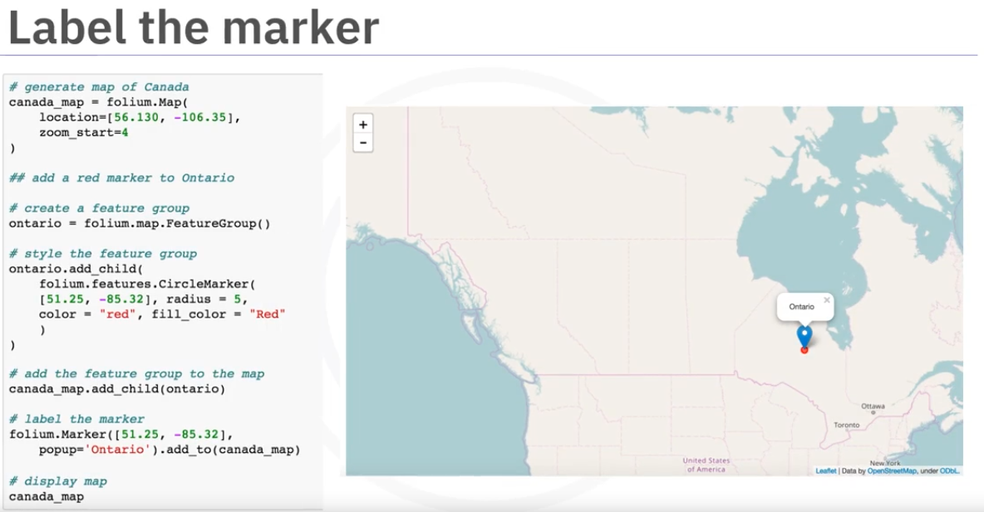

Alternatively we can create a marker using a FeatureGroup which is inside the map module of the folium.

But the FeatureGroup is currently empty. So let create a CircularMarker object which is inside the features module of folium. It takes location, radius, color and fill_color.

Once we have the circular marker, we can add it as a child to the FeatureGroup object.

This creates a red circle on the map. then we can add the normal marker to the map aswell.

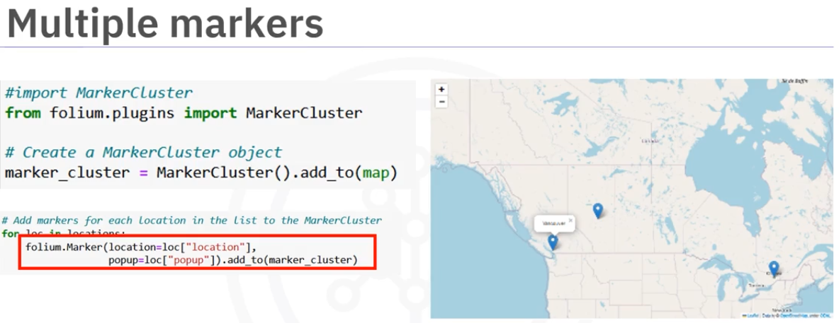

To add multipple markers we need to use the MarkerCluster objects from the plugins module that is available in the folium.

Then we create the MarkerCluster object and add to the map

Then we can create as many markers as we want and add it to the MarkerCluster object instead of directly adding it to the map.

We can add the the markers directly to the map but the Marker clusters will be intelligently grouped based on the proximity of the markers. This dispplays the markers without overcrowding the maps.

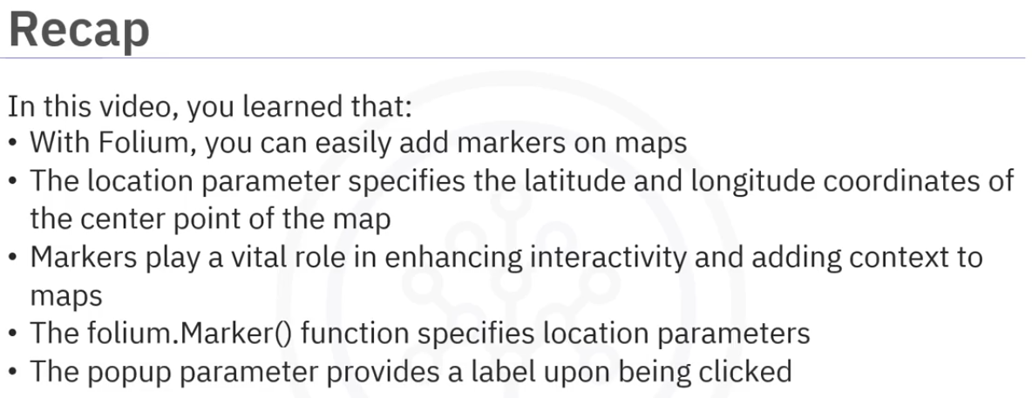

Choropleth Map

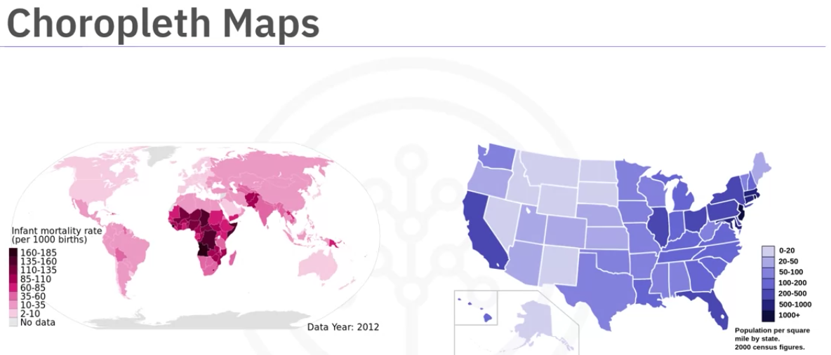

A thematic map where the areas are shaded or patterened in proportional measurement of the statistical variable displayed on the map.(Ex: population density and per capita income). The higher the measurement, the darker the color.

The left side map shows the infant mortality rate of birds per 1000 birds.

The right side shows population per square mile by state in US.

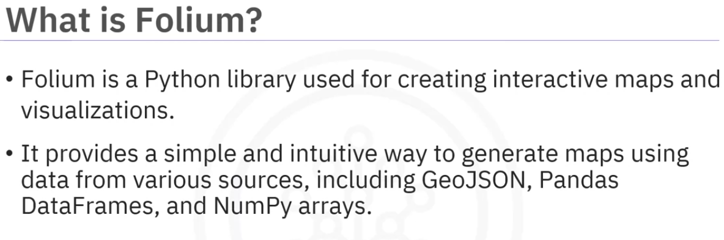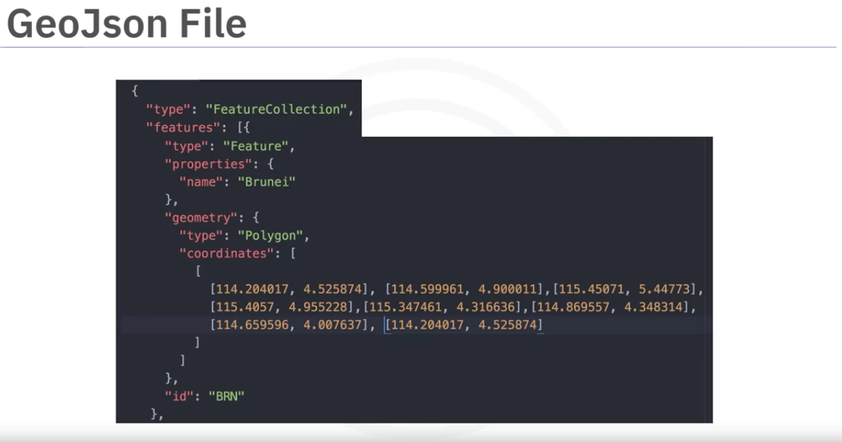

To create choropleth maps, folium requires a GeoJson file that lists each country and its and any geospacial data to define its boundaries. The above example shows data for brunei. It contains the name , geometry, shape, coordinates that defines it borders and boundaries.

Lets see how we can create choropleth map that shows immigration to canada.

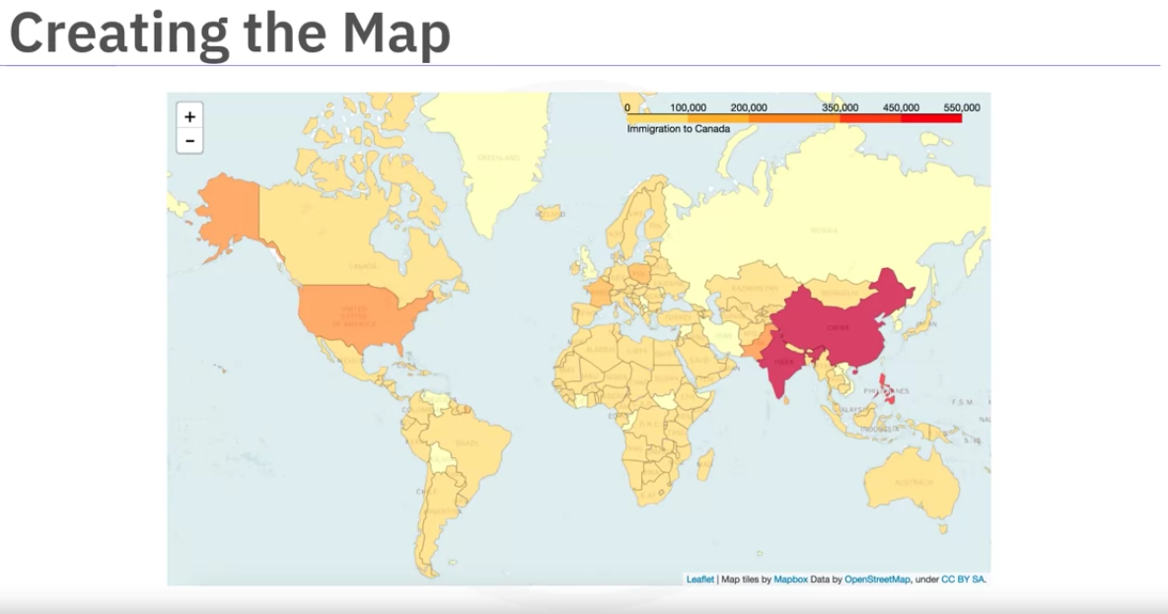

We need to first process the data .

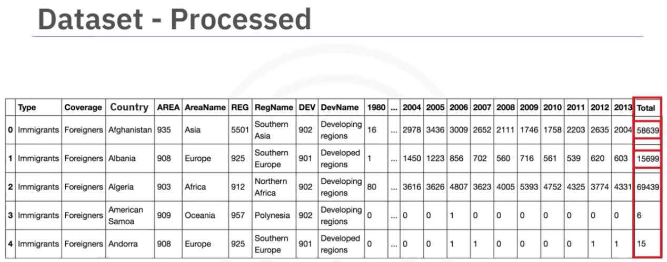

Then we create the Map object from folium using Mapbox bright as the style show it shows the map in white with country names.

we create a variable that has the path for the geo spacial data.

Then we create choropleth map which is from the map module of folium and provide the df_can and the path for geospacial data.

The key on atrribute tells to look at the country name from the jeospacial data.

Along with these, we need to columns from the dataframe that we need to show in the map. We can give fill_color and the legend name .

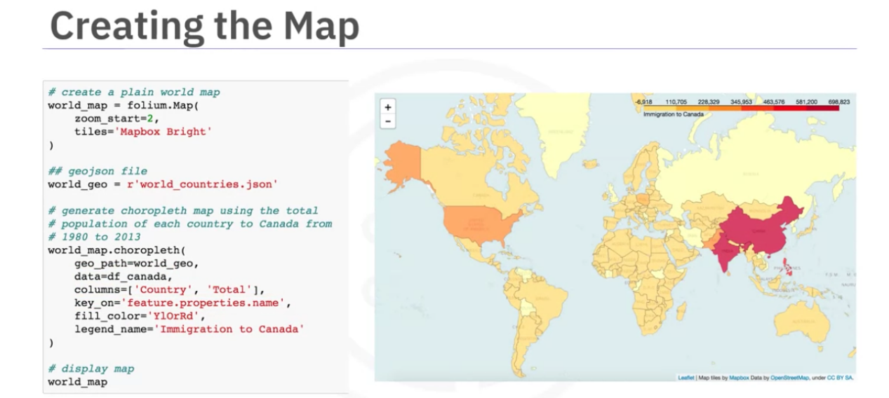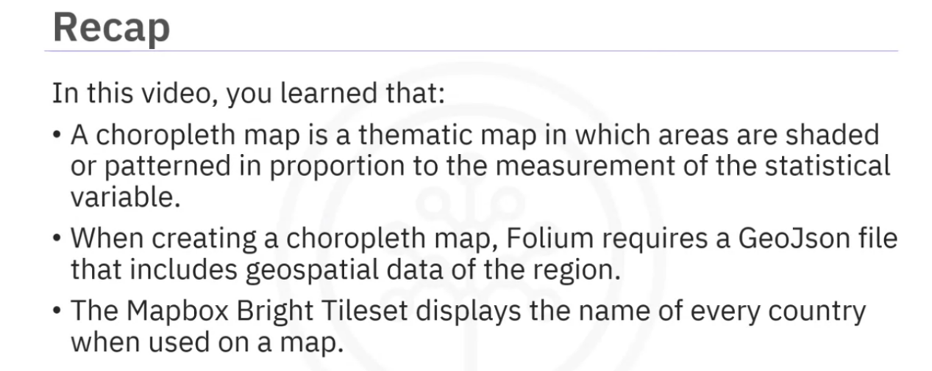

Summary

Congratulations! You have completed this module. At this point in the course, you know:

Folium is a data visualization library in Python that helps people visualize geospatial data.

With Folium, you can create maps of different styles, such as street-level maps, stamen maps, and more.

A feature of Folium is that you can create different map styles using the tiles parameter.

With Folium, you can easily add markers on maps.

The ‘location’ parameter specifies the latitude and longitude coordinates of the center point of the map.

Markers play a vital role in enhancing interactivity and adding context to maps.

The folium.Marker() function specifies location parameters.

The popup parameter provides a label upon being clicked.

Markers can be created using “feature group.”

A choropleth map is a thematic map in which areas are shaded or patterned in proportion to the measurement of the statistical variable.

When creating a choropleth map, Folium requires a GeoJson file that includes geospatial data of the region.

The Mapbox Bright Tileset displays the name of every country when used on a map.

Cheatsheet here.